**Practical-7**

Aim:-Write a program to demonstrate use of ListBox.

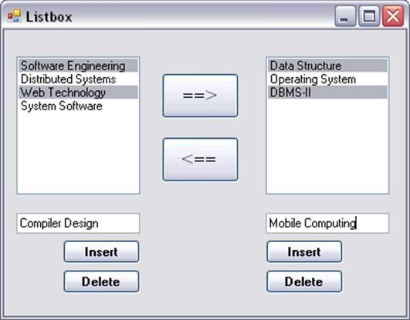

The form should contain List boxes, Text boxes, and buttons as displayed.

-         You should be able to select multiple values from list box. The multiple selected values can be shifted in another list box as displayed.

Code: Form1.cs

using System;

using System.Collections.Generic;

using System.ComponentModel;

using System.Data;

using System.Drawing;

using System.Linq;

using System.Text;

using System.Threading.Tasks;

using System.Windows.Forms;

namespace Practical7

{

public partial class Form1 : Form

{

public Form1()

{

InitializeComponent();

}

private void button3_Click(object sender, EventArgs e)

{

this.listBox1.Items.Add(textBox1.Text);

}

private void button5_Click(object sender, EventArgs e)

{

this.listBox2.Items.Add(textBox2.Text);

}

private void button4_Click(object sender, EventArgs e)

{

this.listBox1.Items.Remove(listBox1.SelectedItem);

}

private void button6_Click(object sender, EventArgs e)

{

this.listBox2.Items.Remove(listBox2.SelectedItem);

}

private void button1_Click(object sender, EventArgs e)

{

if (listBox1.Items.Count > 0)

{

for (int i = listBox1.SelectedItems.Count - 1; i >= 0; i--)

{

this.listBox2.Items.Add(listBox1.SelectedItem);

this.listBox1.Items.Remove(listBox1.SelectedItem);

}

}

else

{

MessageBox.Show("Please Selecte items");

}

}

private void button2_Click(object sender, EventArgs e)

{

if (listBox2.Items.Count > 0)

{

for (int i = listBox2.SelectedItems.Count - 1; i >= 0; i--)

{

this.listBox1.Items.Add(listBox2.SelectedItem);

this.listBox2.Items.Remove(listBox2.SelectedItem);

}

}

else

{

MessageBox.Show("Please Selecte items");

}

}

}

}

Form1.cs[Design]:

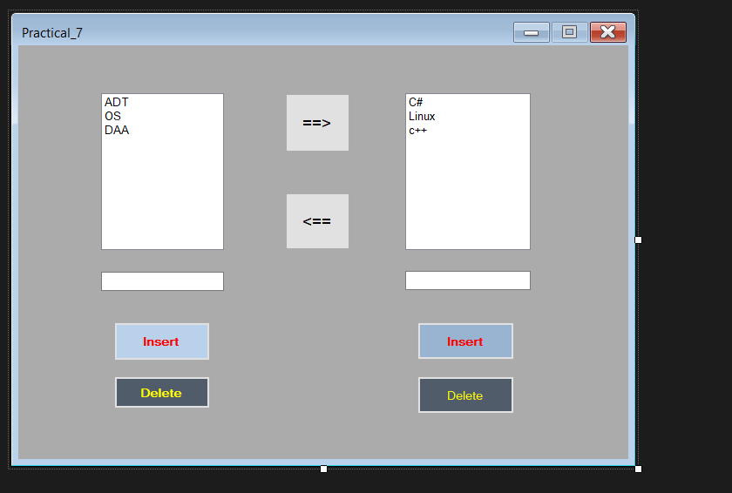

Output:

